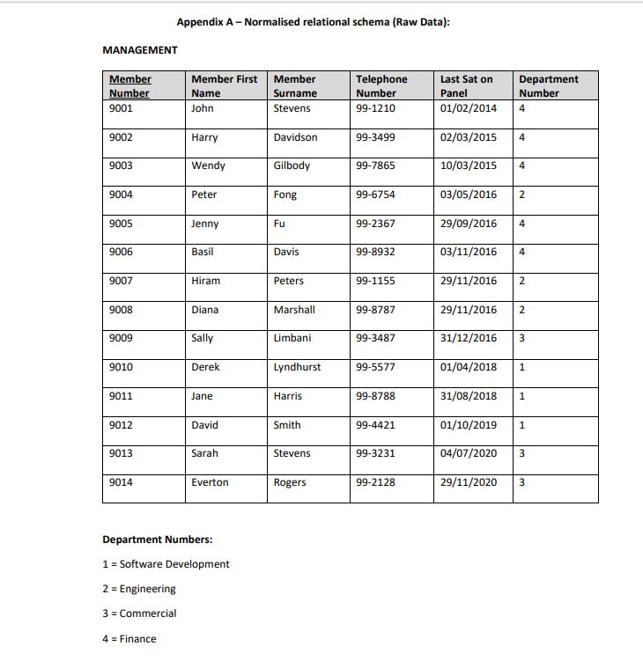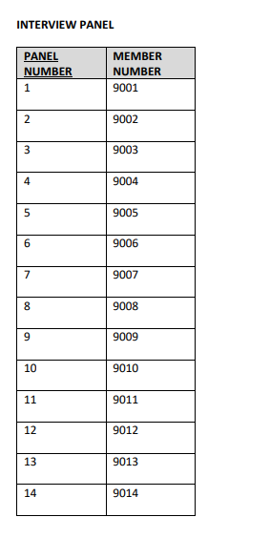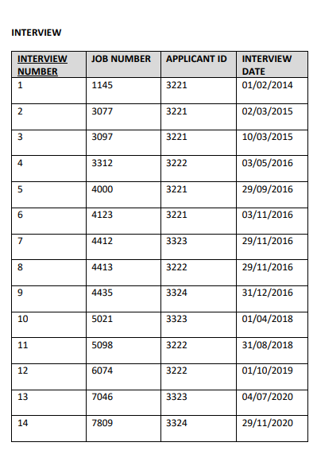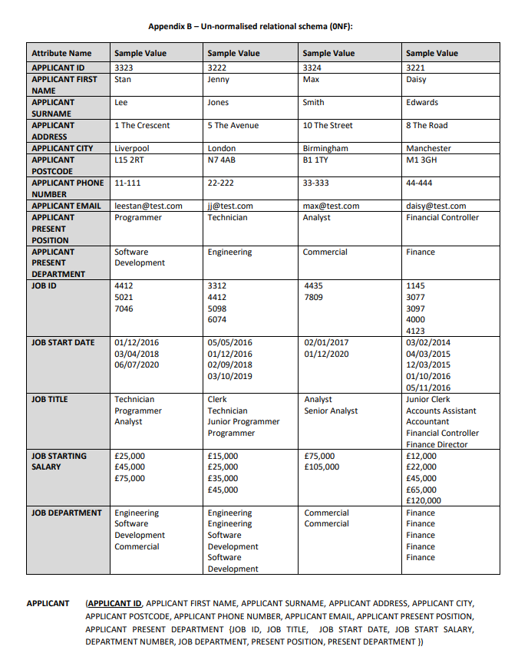

|  |  |  |  |
| --- | --- | --- | --- |
| JOBS | | | |
| JOB ID | JOB TITLE | STARTING SALARY | DEPARTMENT NUMBER |
| 1 | Programmer | £45,000 | 1 |
| 2 | Technician | £25,000 | 2 |
| 3 | Analyst | £75,000 | 3 |
| 4 | Clerk | £15,000 | 2 |
| 5 | Junior Programmer | £35,000 | 1 |
| 6 | Senior Analyst | £105,000 | 3 |
| 7 | Junior Clerk | £12,000 | 4 |
| 8 | Accounts Assistant | £22,000 | 4 |
| 9 | Accountant | £45,000 | 4 |
| 10 | Financial Controller | £65,000 | 4 |
| 11 | Finance Director | £120,000 | 4 |

|  |  |  |  |
| --- | --- | --- | --- |
| AVAILABLE JOBS | | | |
| JOB APPLICATION ID | JOB ID | START DATE |
| 1145 | 7 | 03/02/2014 |
| 3077 | 8 | 04/03/2015 |
| 3097 | 9 | 12/03/2015 |
| 3312 | 4 | 05/05/2016 |
| 4000 | 10 | 01/10/2016 |
| 4123 | 11 | 05/11/2016 |
| 4412 | 2 | 01/12/2016 |
| 4413 | 2 | 01/12/2016 |
| 4435 | 3 | 02/01/2017 |
| 5021 | 1 | 03/04/2018 |
| 5098 | 5 | 02/09/2018 |
| 6074 | 1 | 03/10/2019 |
| 7046 | 3 | 06/07/2020 |
| 7809 | 6 | 01/12/2020 |

|  |  |  |  |  |  |  |  |  |  |
| --- | --- | --- | --- | --- | --- | --- | --- | --- | --- |
| APPLICANTS | | | | | | | | | |
| APPLICANT ID | APPLICANT FIRST NAME | APPLICANT SURNAME | ADDRESS | CITY | POSTCODE | PHONE | EMAIL | POS |
| 3223 | Stan | Lee | 1 The Crescent | Liverpool | L15 2RT | 11-111 | leestan@test.com | 1 |
| 3222 | Jenny | Jones | 5 The Avenue | London | N7 4AB | 22-222 | jj@test.com | 2 |
| 3324 | Max | Smith | 10 The Street | Birmingham | B1 1TY | 33-333 | max@test.com | 3 |
| 3321 | Daisy | Edwards | 8 The Road | Manchester | M1 3GH | 44-444 | daisy@test.com | 10 |

|  |  |
| --- | --- |
| Department | |
| Name | Number |
| Software Development | 1 |
| Engineering | 2 |
| Commercial | 3 |
| Finance | 4 |